|  |
| --- |
| Photo displaying partial image of two pie charts on a canvas-textured page |
| PO3_DGW  Hardware Software Interface Document |
|  |

Status table

|  |  |
| --- | --- |
| PO3_DGW_HSI | |
| Version | V0.2 |
| Status | Released |
| Author | Mariam El-Shakafi |
| Last updated | February 5, 2020 |

Table of history

|  |  |  |  |
| --- | --- | --- | --- |
| Version | Author(s) | Date | Changes |
| 0.0 | Mohammed Elsayed | January 31, 2020 | Created HSI document |
| 0.1 | Mohammed Elsayed | February 4, 2020 | Added pinout of the components |
| 0.2 | Mariam El-Shakafi | February 5, 2020 | Added pin description table, updated diagrams |

**Content**

Status table 1

Table of history 1

1. Hardware requirements 3

1.1. Block Diagram 3

1.2. Components 4

1.2.1. Display device 4

1.2.2. Sound device 4

1.2.3. User interacting device 4

1.2.4. Control device 4

1.2.5. Power source 4

1.2.6. Casing and packaging 4

2. Hardware Connection Diagram 5

2.1. Display device 5

2.2. Sound device 6

2.3. User interacting device 6

2.4. Control device 7

2.5. Power source 7

3. Hardware Connection Description 8

1. Hardware requirements

The hardware that system required illustrated in the following list:

* Display Device
* Sound device
* User interacting device
* Control device
* Power source
* Casing and packaging
  1. Block Diagram



Figure 1. Block Diagram of Hardware requirements

* 1. Components

This section lists the requirements in detail.

* + 1. Display device

A 16x2 Dot Matrix Liquid Crystal Display Controller will be used as display device.

* + 1. Sound device

A 5V buzzer will be used as sound drive for alarm mode.

* + 1. User interacting device

A three push buttons will be used to allow user to interact with the system.

* + 1. Control device

A microcontroller ATmega32 will be used as controller device of the system.

* + 1. Power source

A 9V battery will be used to power the system up.

* + 1. Casing and packaging

Not specified

1. Hardware Connection Diagram

This section provides a detailed pin connection for each hardware component.

* 1. Display device

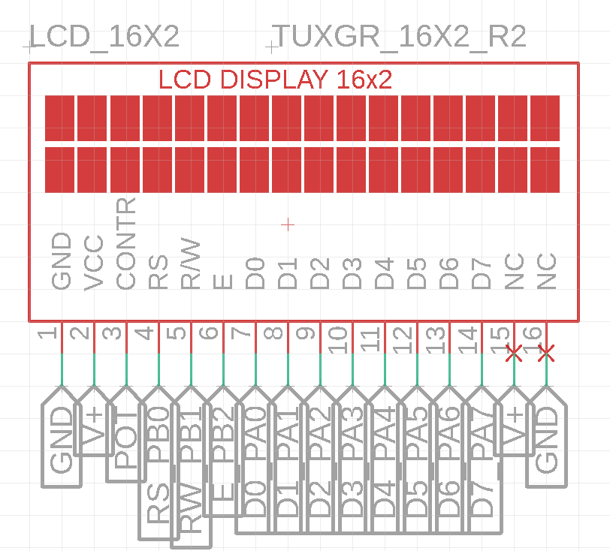

* 1. Sound device

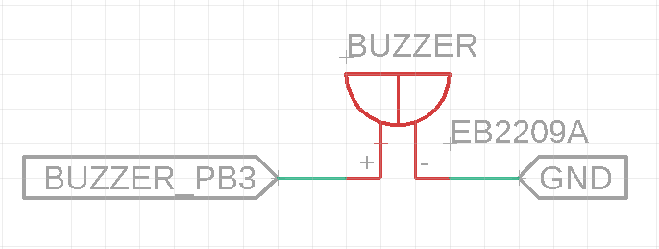

* 1. User interacting device

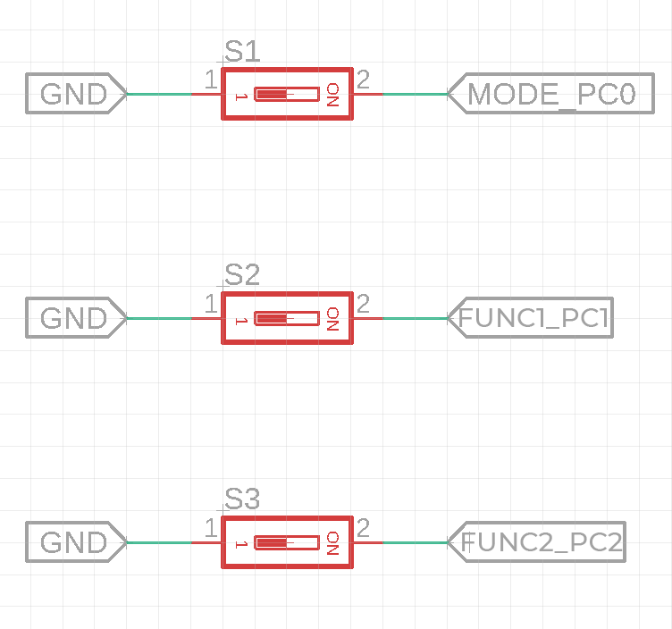

* 1. Control device

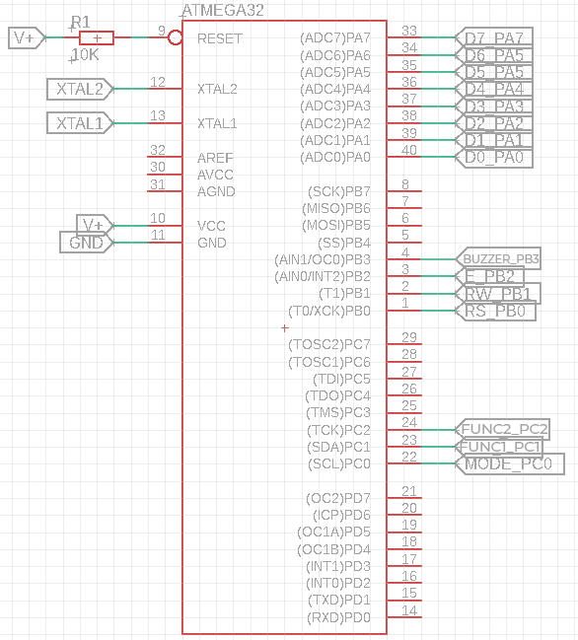

* 1. Power source

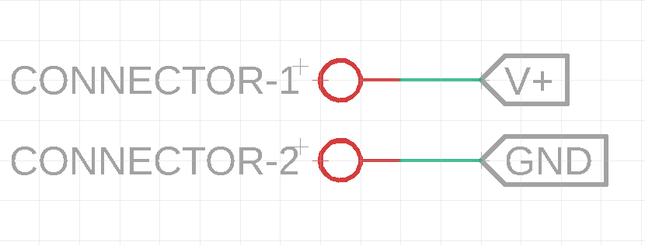

1. Hardware Connection Description

|  |  |  |  |
| --- | --- | --- | --- |
| Port/Pin | Signal name | Mode | Description |
| Port A | LCD_DATA | Output | LCD Data bits (D0-D7) |
| PB0 | LCD_RS | Output | Register select control signal for LCD |
| PB1 | LCD_RW | Output | Read/Write control signal for LCD |
| PB2 | LCD_E | Output | Enable control signal for LCD |
| PB3 | ALARM_BUZZER | Output | Buzzer control |
| PC0 | BTN_MODE | Pull-up input | First control button (MODE button) |
| PC1 | BTN_FUNC1 | Pull-up input | Second control button (FUNC1 button) |
| PC2 | BTN_FUNC2 | Pull-up input | Third control button (FUNC2 button) |
| *Other port B, C pins & port D are not connected to external hardware. | | | |